Phase 1 · Design & Orient
Exercise 1: First Contact: Orient Inside Claude Code
Dev cycle | Design (orientation)
CC features | /help, /status, /context, /model, /cost, plan mode (Shift+Tab), permission model
Time | 25 min
You produce | A working Claude Code session and a feel for built-in commands

Objective
Before you write a line of ExpenseFlow, get fluent in the cockpit. Claude Code is not a chat box: it runs in your terminal, reads and edits files on your machine, and runs commands. This exercise builds muscle memory for the built-in slash commands and the permission model so you stay in control later.
Walk-through
1 | Open the right terminal
Open VS Code, open a PowerShell terminal (Terminal > New Terminal), and confirm Claude Code is installed. Slash commands only work once you are inside a session, so first confirm the CLI itself.
Run in terminal
PS> claude --version
PS> claude doctor
VALIDATE claude --version prints a 2.1.x build. claude doctor reports your install, Node runtime, and auth as healthy. If auth is missing, run claude auth login first.
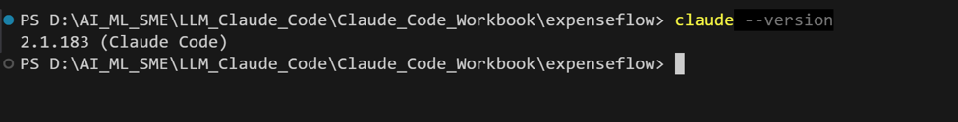
Run in terminal
PS> claude --version
PS> claude doctor

VALIDATE claude --version prints a 2.1.x build. claude doctor reports your install, Node runtime, and auth as healthy. If auth is missing, run claude auth login first.
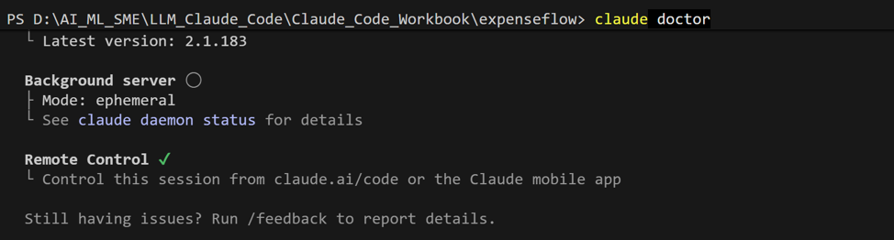
/2 | Start a session and ask what is possible
Launch Claude Code from any scratch folder. Once the prompt appears, type a slash and read the live menu, then open the full reference. The live menu is always the source of truth for your exact version.
Run in terminal
PS> claude
Type inside the Claude Code session
PS> /help
PS> /status
VALIDATE /help lists built-in commands plus any bundled skills. /status shows your model, working directory, and permission mode.
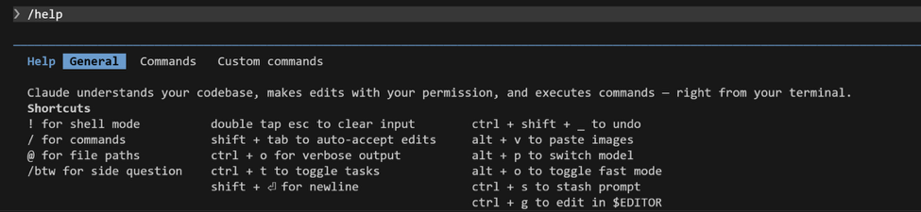
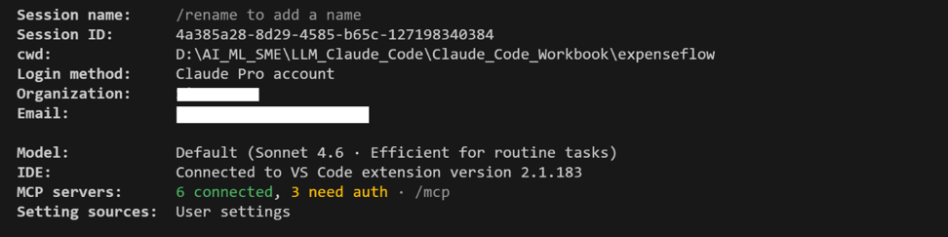
3 | Inspect your context and model
Two commands you will lean on constantly. /context shows how much of the context window is in use, which is how you avoid quality drops on long builds. /model lets you pick the engine for the task.
Inside the session
PS> /context
PS> /model
VALIDATE /context renders a usage map (system prompt, files, history). /model lists Opus 4.8, Sonnet 4.6, Haiku 4.5 and lets you switch. Leave it on the default for now.
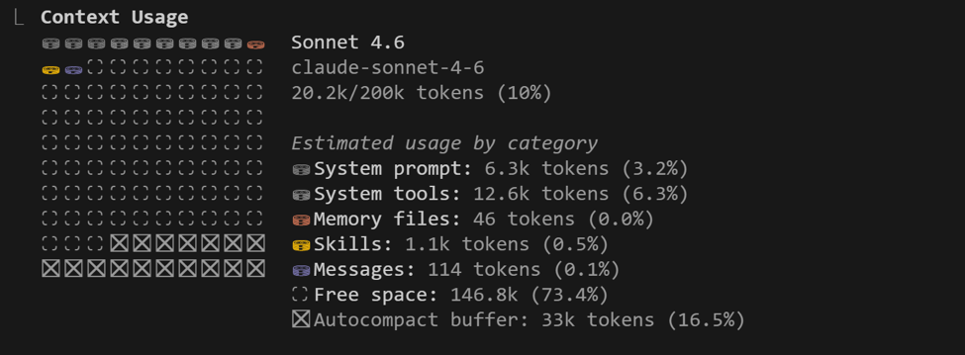
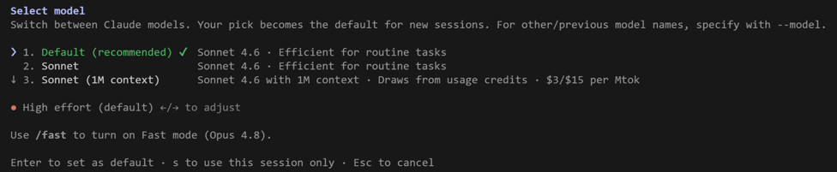
4 | Meet plan mode and the permission model
Press Shift+Tab to cycle the mode indicator at the bottom of the screen between normal, auto-accept, and plan mode. Plan mode lets Claude think and propose without touching files. Then give it a harmless task and watch it ask permission before acting.
Type this prompt into Claude Code
List the files in this folder and tell me what kind of project this looks like.
VALIDATE In plan mode Claude proposes steps but makes no edits. In normal mode it asks for your go-ahead before running a command or writing a file. That approval gate is your safety net: never disable it on day one.
5 | Check the meter
Cost awareness is a core practitioner habit. Run /cost to see token spend for the session so far.
Inside the session
PS> /cost
VALIDATE /cost prints tokens and approximate spend for this session. You will return to this in Exercise 15 when you optimise a long build.
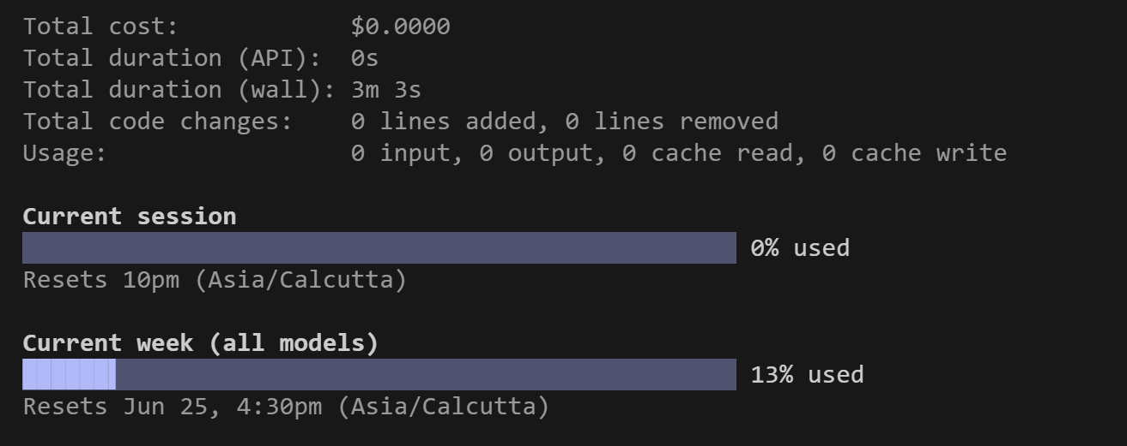
What success looks like
- You can enter and leave plan mode at will and explain the difference between plan, auto-accept, and normal mode.
- You can name what /help, /status, /context, /model, and /cost each do without looking them up.
- You understand that Claude asks permission before editing files or running commands, and that you decide.
Common pitfalls (Windows and macOS)
- If claude is not recognised, your PATH was not refreshed: close and reopen the VS Code terminal after install.
- PowerShell may block scripts. If a command is refused, run Set-ExecutionPolicy -Scope Process -ExecutionPolicy Bypass for this session only.
- Slash commands do nothing in your normal shell: they only work after you have started a session with claude.
Stretch goal
Type / and arrow through the entire menu. Find /resume (reopen a past session) and /clear (wipe history) and read what each one warns about before you ever need them in anger.

